MANUAL rev. 1.5.0

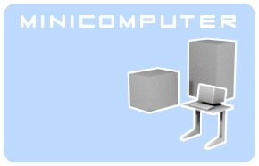

Minicomputer is an open source sound synthesizer for Linux, distributed under the GPL 3 license. It requires jack as an audio server and Alsa or jack for midi connections.
Minicomputer is a stand-alone application, divided into two programs, the actual sound engine and the editor. Both independent programs communicate via OSC (open sound control) and it is possible to write different editors or control the engine from other applications which can talk OSC.

You can reach the original author at steiner@block4.com .
Regarding this modified version, write to marc.perilleux@laposte.net .

Contents
Installation 2
Getting started 2
Sounds and multis 2
Multiple instances 4
Architecture 4
Making sound 6
MIDI settings 11
Compiling 11
Troubleshooting 12
OSC implementation 12

Installation
It's unlikely that you received Minicomputer from repositories of the Linux distribution of your choice. An experimental debian package is available online, it may work for debian and derivatives.
Otherwise you'll have to compile Minicomputer yourself, which fortunately is quite straightforward.
Your first step is to retrieve the source files. For the version this documentation refers to, you can find them at https://github.com/vloop/minicomputer-virtual-synth .
Compilation details are given in the “compilation” section of this document and in the README file. This includes step-by-step instructions for Linux Mint.
The installation part of the sconstruct script copies the various required files where they belong, for instance the binaries are copied to /usr/bin.
The factory presets will be copied to your home directory on first launch.
The original presets can be re-installed in your home directory at any time by launching installpresets.sh.

Getting started
To start the synth you can click on the shortcut created by the install script. This will start the editor and the sound engine if needed. The sound engine process name, as shown by top and other tools, is minicomputerCPU.
If you face any problem, try typing minicomputer at the command line, this will show you any error message in the console.
At start-up, the mix out left and mix out right outputs are connected to the first two output of your sound card. If you prefer to setup the connections in a different way, for example with qjackctl, you may use the command line option -no-connect.
Once the connections are made with Jack audio, you should be able to hear a sound simply by clicking on « Audition ».
All is left to do is to connect the sound engine's MIDI input (ALSA or Jack) to the output of a MIDI keyboard, sequencer or any other MIDI-enabled application. The MIDI messages must be sent to the sound engine, namely MinicomputerNNNN, except for program and multi changes, which can be sent to miniEditorNNNN.
At startup, the editor looks for its data files in your home folder, as set by the environment variable $HOME. They are kept in the .miniComputer subfolder. If the editor doesn't find them, it attempts to retrieve them from /usr/share/minicomputer/factory_presets. The script installpresets.sh does the same. Don't forget to restart the editor if you change these files manually.
The presets contain a few demo multis and sound presets. There is a special preset called init which is good to start creating sounds from scratch. This is retrieved from the initsinglesound.txt file, which you can import anytime or override with a custom version.
When you quit the editor, it will also shutdown the engine if it started it.

Sounds and multis
Minicomputer uses 8 independent voices, and each will play its own sound. Each voice is initially loaded with one of the 512 possible sound presets. Sound parameters such as frequencies, modulations and filter settings are stored in these 512 locations. Contrastingly, the session parameter (output volumes and pan, MIDI channels and ranges) are stored in a “multi” among 128. The selected sound number is shown in the “sound #” box, while the selected multi numbers is displayed in the “multi #” box.
Selecting a sound or a multi doesn't activate it : in order to do so, you need to click on “load sound” or “load multi” respectively.
Using a sound or a multi is a two-step process :
1) select the memory location, i.e. the sound or multi number (displayed in big red digits) using the wheel right under the name (the left and right arrow keys move one location at a time) or the red arrows on each side of the number, or by typing the number in the “multi #” or “sound #” box.
2) Click “load sound” or “load multi”.
The same principle applies in the “Sounds” and “Multis” tabs : select a sound or a multi, then click “load n” (n is the voice number where the sound will be loaded) or “load multi” (or its shortcuts enter and double-click ; the multi always applies to all voices).
Similarly, any change to the sound or multi parameters will be stored in the selected sound and the selected multi respectively only after you have clicked on “store sound” or “store multi”. This allows you to save the changed sound or multi in a different location, and/or with a different name :
1) select the target location as described above
2) type in a new name if desired
3) click on “store sound” or “store multi”.
You can achieve the same result using the dedicated tabs, through the context menu (right click on a cell) or the usual shortcuts Del, Ctrl-C, Ctrl-X et Ctrl-V to delete, copy, cut, and paste respectively.
Beware ! The “store sounds” and “store multis” (note the plural) on these tabs have a different purpose, namely saving all the sounds or all the multis in the appropriate files.
Note that a multi holds the output levels, the midi parameters and the sound number for each voice, but not the detailed parameters for each sound. Therefore, if the parameters of a certain sound are changed and stored, the changes will apply to all multis referring to that sound's number. However, when a multi is exported to an external file, this file will also include the actual parameters for the sounds used by the multi. When importing this file, you will be offered to import the embedded sounds, or to keep the current ones.
The sound name is displayed in red if the sound was changed (or wasn't yet loaded). The multi name works similarly.
The “Compare” button makes comparing the edited sound with the original easy. When “Compare” is clicked, all the sound parameters (not the multi parameters) are stored in a buffer and the selected sound is loaded from memory. When it's clicked again, the sound parameters are recalled from the buffer. The eight voices share a single buffer.
All the sounds and multis data are stored in your home folder, in the .miniComputer subfolder. The editor gets your home folder from the $HOME environment variable. The factory settings are copied automatically at first launch. You may reinstate them at any time by launching installpresets.sh (as a regular user, not as root). You can also change those files manually, however the changes won't be applied until you restart the editor. The factory presets include the “init” sound. It's useful as a starting point for creating new sounds ; the parameters for this sound are stored in the initsinglesound.txt file, you may overwrite it with a different sound if you want.

Multiple instances
When you want to run several instances of Minicomputer, the ports used by OSC have to be unique. You can define the OSC network port with the command line parameter -port. Of course the editor and the engine need the same port to see each other, an example would be using the port 9000 for both instead of the default 7771. Usually the sound engine is launched by the editor, this ensures port consistency.
To minimize confusion in case of multiple instances, each one bears the port number in the name which is exposed i.e. visible on qjackctl. The core sends back some information to the GUI using the following port (default 7772). So for the next instance you'd specify at least -port 7773.
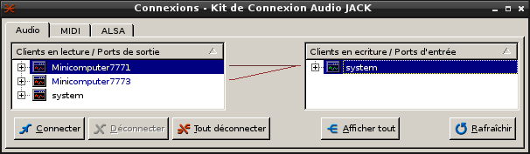

Architecture
Well, it's software but under Linux with Alsa and Jack it's rather similar to studio environments so a diagram makes sense.
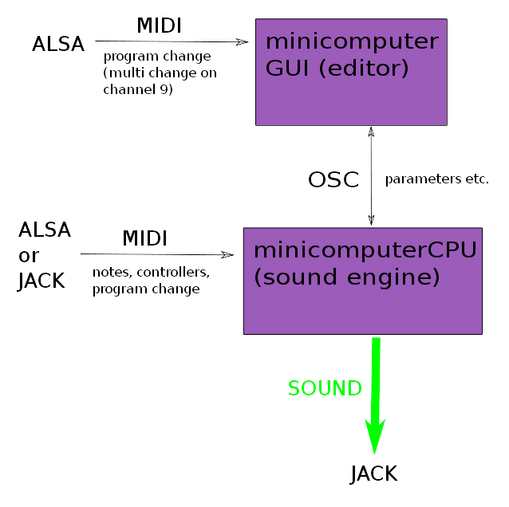

The editor talks to the sound core via Open Sound Control (OSC) protocol over localhost network, and the sound core reports status to the GUI over OSC as well. These two applications don't need to be connected manually and the order of launching doesn't matter, they should find each other. They communicate by default over the port 7771 which can be changed at compilation time in the common.h file or with the -port command line parameter at launch so you can run several instances of Microcomputer simultaneously. Normally they reside on the same machine but it could be possible, with minor changes in the source code, that they run on separate computers, connected via network.
Both the sound engine and the editor provide a midi port. The editor accept Midi program changes on channel 1 to 8 for switching between sounds, and on channel 9 for changing multis. Since Midi allows only 128 programs, you need to send a bank select (cc=32, value=0..3) message first to access the 512 sound settings. On channel 9 you can switch between the 128 possible multi setups so all 8 voices can be changed at once to any of the 512 sounds, for instance at the beginning of a new song.

The synth engine receives note and performance data through its Midi port (Alsa or Jack midi), channels for the individual voices are set in the editor's MIDI tab.
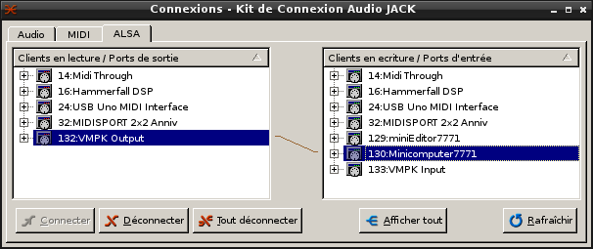
In addition, the current version responds to OSC /Minicomputer/midi followed by four integers. Current implementation supports note on, note off, all note off all sound off and control change messages.
The sound core provides several audio ports for JACK for the output of sound.
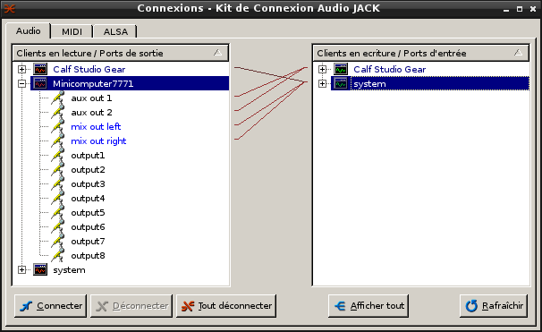
There is a stereo mixed output for mixing voices together, aux 1 and aux 2 as a separate two channel output, for instance for effects, and individual outputs for each voice.
Each voice has a knob for individual, aux 1, aux 2 and mix output volume, the mix is augmented with a dedicated panorama slider while the auxiliary panning needs to be done with the two volume knobs if desired.
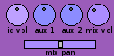
The volume settings are stored in the multi settings, not in the sound data.

Making sound
Minicomputer doesn't ape any existing synthesizer but has a rather traditional, subtractive approach and thus is easy to operate. It's made of 8 parallel voices forming a multitimbral setup, suited for example as a drum synth. Each voice is monophonic in itself so it can play only one key per time, additional triggers might cut off a sound of the same voice which was already on or fading. You may also pool all or part of the voices in a polyphonic setup.
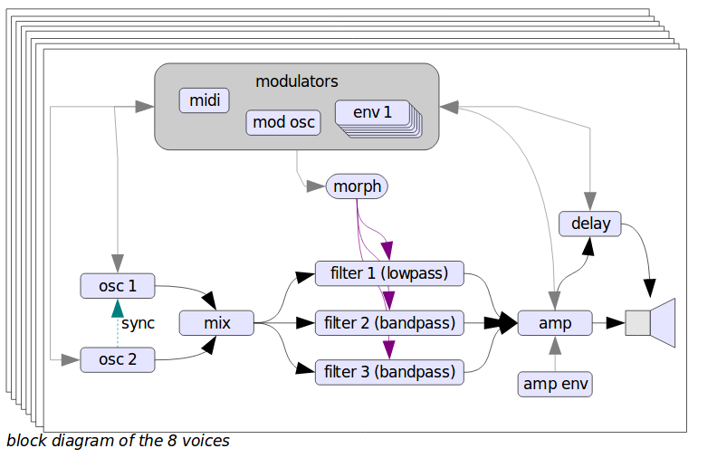
The synthesis based on the idea to create first a rather complex waveform via two oscillators. This waveform will then get shaped with a complex morphing filter, actually made up of three filters. A low-pass filter (for not losing ground) parallel to two bandpass filters which shape further formants. The oscillators are not band-limited which might lead to aliasing but give on the other hand a rich tone, important for the FM and amplitude modulation which can happen in both directions, even at the same time enabling feedback. The first oscillator has an extra sub oscillator. The second oscillator has slightly different features: it can be hard synced to the first one and the second amplitude modulator only modulates the FM output while the first one shapes the output volume.
Additionally there are various modulation sources like an other oscillator with a range going much into audio, the only difference being that it's not controlled by keyboard or pitch bending. Six envelopes of the traditional ADSR format are there for a lot of parameter changing. They can even turn into additional oscillators with the repeat button, and reach in the audio frequency range when speeded up. When in repeat mode, the attack and decay steps are always repeated, while release is repeated only if sustain is not zero.
A seventh envelope generator is routed to the amplitude of the output and is not available on other modulation destinations.
The sound choice of the eight mono voices can be stored into the multi setup which is handled separately. It's important to also save your sound settings when you save the multi settings, to make sure everything will be recalled correctly.
Minicomputer stores the sounds in a file called minicomputerMemory.txt, which can be opened in a text editor. Same goes for the multi settings which are stored in minicomputerMulti.txt. When the editor stores something to disk it writes it first to temporary files ending with .temp, then makes a backup of the former files to .bak and then finally commit the changes be renaming the temp files to the actual names. This is done for your convenience and safety and you shouldn't have files with the names mentioned above in the .minicomputer directory, otherwise they'll get overwritten.
The 8 voices are arranged as one tab for each. Tabs can be reached by mouse click or keys F1 to F12.

The oscillator section features for each the frequency setting which can be set to a fixed value or tuned relative to the note being played. Tune is done with the XY cross-slider, the horizontal is coarse in octaves while the vertical one is for fine tuning. Additionally for more precise control there is a display field showing the frequency value and accepting input from keyboard and mouse. Click on it and click-drag to left and right for changing the value further. The three possible mouse buttons, left, right and middle click, change the value with a different factor. While all tuning cross-sliders have their own numeric field, all other values can be fine tuned with the field near the logo. It changes the last tuned knob. This seems the best compromise between quick access and total control at the moment.
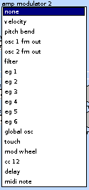
Waveforms can be chosen from a drop-down box. There are traditional forms like sawtooth and square, special ones for adding crackle noise (bit and spike), waveforms created with additive methods and 8 from Microcomputer, a non free Plug-in the original author programmed and offered some years ago for Windows and Mac OS9.
Modulation settings on Minicomputer consist of two GUI elements, a drop-down box for choosing the actual modulator and an amount dial going from 1 to 1. The negative amount changes the polarity of the modulator.
Where there are two modulation sources for the same destination, the two are normally added, however by checking the mult. box they can be multiplied instead. This is useful for varying a modulation using the modulation wheel on a MIDI master keyboard or for making an effect that varies over time, such as a progressive tremolo.

There are two slots for frequency modulation with the first one bearing a boost button to create extra harsh metallic sounds by boosting the modulation level 100 times. Two amplitude modulation slots shapes the volume. For the first oscillator they control both the volume at the output to the mixer and the separate FM output which becomes a modulator, while for the second oscillator only the first slot does so, the second controls only the FM output so more complicated blending can be done. Also only at the second one there is a sync button to hard-sync it to the first one, so the phase gets restarted when the first oscillator resets its phase. The oscillators can also modulate themself, creating interesting chaotic feedback behaviour. In the event modulation goes out of control (for example the boosted FM), you can reset the internal signal path with the button in the filter section. It doesn't change settings but resets the whole internal signal path for that voice.
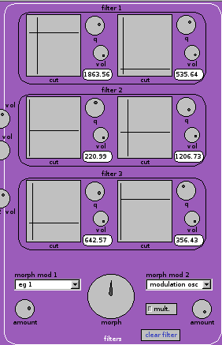
The morphing filter consists of three distinct filters in parallel, each with settings for cut-off frequency, q which means resonance and volume with positive and negative polarity. These settings are duplicated and you (and/ or two modulators) can blend between the left settings and the right settings using the big morph knob for all 3 filters at once. When you use modulators, the morph dial acts more as an offset so experiment with the modulation amounts and morph setting to get the desired effect like filter sweeps or formant morphs.
The frequency is here again to be set with the XY cross-slider like above mentioned and also features a separate display for fine tuning.
Be careful with the resonance settings because this can lead to harsh distortion. The original author ripped once a hi-fi speaker with a Korg MS 20 analogue synthesizer in 1986, this can actually happen! (Not to mention ear damage) However he decided not to scale down that much the resonant signal because it's important for creating formant peaks. Anyway there is some scaling involved to protect a little bit, otherwise the filters would roar, tear and rip much earlier.
The Esc key acts as a panic button, sending all sound off messages to each voice.

Next to the filter there are the modulators with the 6 free routable envelopes and the independent modulation oscillator. The envelopes can get quite fast and act as modulation oscillators too when switched in the autorepeat mode with the repeat button. Otherwise they are are pretty old-school with a conservative attack, decay, sustain and release (ADSR) approach.

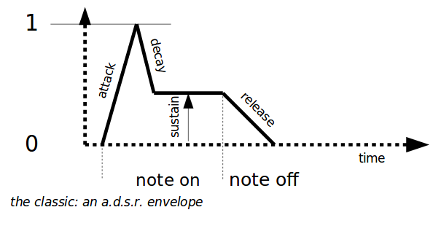

Further to the right there is the amp section with one modulation slot (for instance modulating the volume by the velocity of the pressed key) and a dedicated envelope generator.
The pan position can also be modulated, for ping-pong or other effects.
Also on the right there is a delay for each individual voice, whose settings are stored along the sound data. The delay time can be modulated which creates some interesting effect including flanging and feed-backed pitch shifting. The output of the delay is also available as a modulator. The original author tried it also as a feedback audio source but the results were not that interesting.

On the footer there is the memory section which allows the storage and recall of sound and multi settings. Multi stores only the sound choices of each voice, its MIDI settings and the volume section whose knobs have a different colour code.
You can choose a sound or multiprogram with the large horizontal wheels underneath the name fields which are handy with the large list of settings. Once you have clicked on the wheel, you may use the left and right arrows to change the selection. After choosing a setting you have to press the load buttons for actually loading it (i.e. applying the sound parameters). The store button writes the current settings to that storage location and you can give it a new name in the field before pressing that button.
The digits show the memory location and are helpful for finding out the numbers for a remote program change.
To exchange sounds with others you can import or export individual sounds to separate text files, whose names you can choose freely. The in/export goes in and from memory directly, you can only export a saved sound or import to a certain memory location. The memory location doesn't need to be loaded, it is sufficient to have it dialled. After importing you need to load that sound with the load button to actually play it.
There is an “Audition” button for quickly checking the currently loaded sound without connecting a (physical or virtual) keyboard. Beware this is the currently loaded sound, which may be different from the one displayed in the memory controls.

MIDI settings
On the MIDI tab, for each of the 8 voices, one can select the midi channel, the lowest note the voice will respond to, and the highest. These parameters, together with the test note number and velocity (which will sound when « audition » is pressed), are saved in the multi, along with the volume settings. The midi parameters apply to Jack and ALSA inputs, but not to the OSC input. The « audition » button (sent as an OSC message) always triggers the current voice, no matter what its midi settings are.
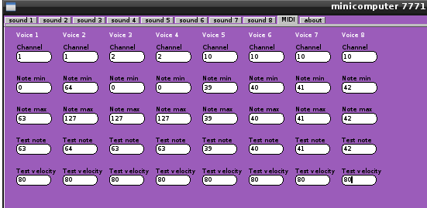
In the above example, the keyboard is split between voice 1 and voice 2 over channel 1, voices 3 and 4 are stacked on channel 2, and voices 5 to 7 respond to specific notes on the percussion channel (10), so they can be controlled easily from a rhythm box like Hydrogen.

Compiling
Dependencies include:
– Jack for audio and midi
– FLTK gui toolbox for editor
– Alsaseq for Midi communication
– pthreads
– liblo for OSC communication
and
– scons for building

The engine is written in C and has its source code in the src/cpu folder, while the editor is in C++ with its source files in src/editor. Parameters for customization are in the common.h file.
To build Minicomputer just type scons at the command prompt.
Cleaning the build files including the newly created program files, is done by typing scons -c.
Installation in /usr/bin must be done as superuser/root by typing scons install.
Preset sounds can be installed to the .miniComputer directory in your home folder with the script installpresets.sh. Should be there any previous settings, they get backed up.
The build process accept parameters for refining architecture optimization:
– 64bit=1
forces a build for 64bit platforms with the m64 option
The common.h file have more customizable parameters. You can switch on debugging messages by uncommenting the line //#define _DEBUG.
The original author tried a vectorized version for improving performance but it didn't improve it at least on his hardware which was AMD CPUs only. For experimentation you can uncomment //#define _VECTOR.

Troubleshooting

“I have library xyz installed but scons complains about not finding xyz”
- make sure that you have the developer version of the library installed which comes extra and additionally. It usually looks like libxyz.dev.
- Wrong parameters for gcc can also result in a misleading error message about libraries.

“I hear no sound, despite having connected the outputs in Jack”
- Check the output levels.
- Check that the voices are actually triggered : when a note is played, a red light in the logo indicates which voice is activated. If the “Audition” button works, check the midi parameters.

“Filter has no effect”
- Make sure that the « Filter bypass » button is not lit.
- Make sure the relevant filter volume is not zero.

« Modulation has no effect »
- Make sure the « amount » setting for this modulation is not zero ; if « mult. » is checked on the second modulation of a pair, make sure the first modulation is not zero.

OSC implementation
The core accepts messages from the editor in the OSC protocol. The port is 7771 as default which can be changed in the common.h file for building alternative versions. One port accept only one editor so its not possible to run several instances of Minicomputer without building alternative versions or specifying a different port for both applications with the parameter -port at launch.
The following messages are sent via OSC:
- For multiple choices the message is /Minicomputer/choice followed by three integers, the first one denotes the voice number, the second the number of the choice parameter and the last one the actual value.
- Other voice parameters are sent as /Minicomputer and two integers and one float. First integer says which voice, the second the parameter index and the last one the actual value as a float.
- Global parameters (tuning) are sent as /Minicomputer/multiparm followed by one integer for the parameter number and one float for the value. They use their own numbering scheme, detune for each note use numbers 0 to 11, global tune is 12.
The following diagram is overlaid with the OSC parameter numbers:
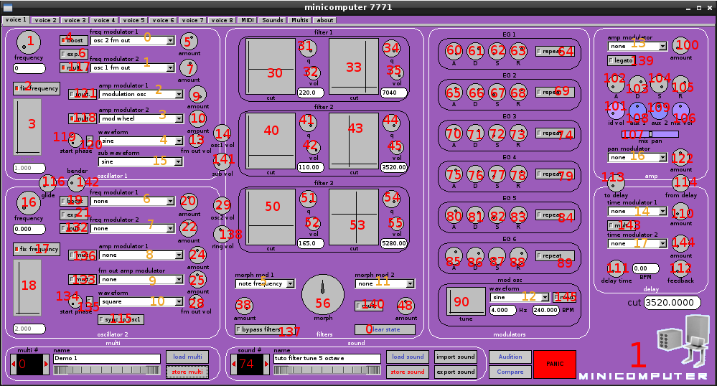
Please bear in mind that the drop down boxes have their own numbers (in orange) which are transferred as /Minicomputer/choice with three integers as stated above.
The global parameters (tuning) also use their own numbering scheme, detune for each note are number 0 to 11, global tune is 12.
In the MIDI tab, the channel, minimal note and maximal note use OSC parameter numbers 125, 128 and 129 respectively, while transpose is 130.
The fields note and velocity are not sent to the core, they are used by the editor when « Audition » (or its shortcut« Ins ») is pressed.

